LO: To read, enjoy and explore features of poems.
Read the poem and discuss. Do you like the poem? Did it make you laugh?
Underline any words or phrases that are unfamiliar.
Tell It to the Dog
by Joshua Seigal
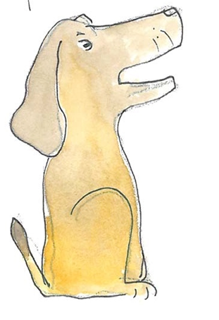
If you have had an awful day
and no one wants to come and play
and all your woes won’t go away,
just tell it to the dog.

If everybody picks on you
and all your plans have fallen through;
if you feel lonely, sad and blue,
just tell it to the dog.

Dogs do not judge.
They understand.
They rub your leg.
They lick your hand.
If you feel lost
in no-man’s-land
just tell it to the dog.

Dogs keep your secrets safe within.
They don’t care if you lose or win.
So turn that frown into a grin
and tell it to the dog.
(Or, failing that,
make do with the cat…)

